User Manual Packaging_general_plot Scintil

This document explains how to use interface Packaging_general_plot.
This interface is made to plot the number of dies that has a final binning equal to 1 ( or other number ) of every wafer for a given Tapeout. For all dies corresponding to final binning selected, expected power output min and max + wavenlength of first laser is also plotted
You have also the possibility to select a wafer and plot the expected power output min and max for every dies.
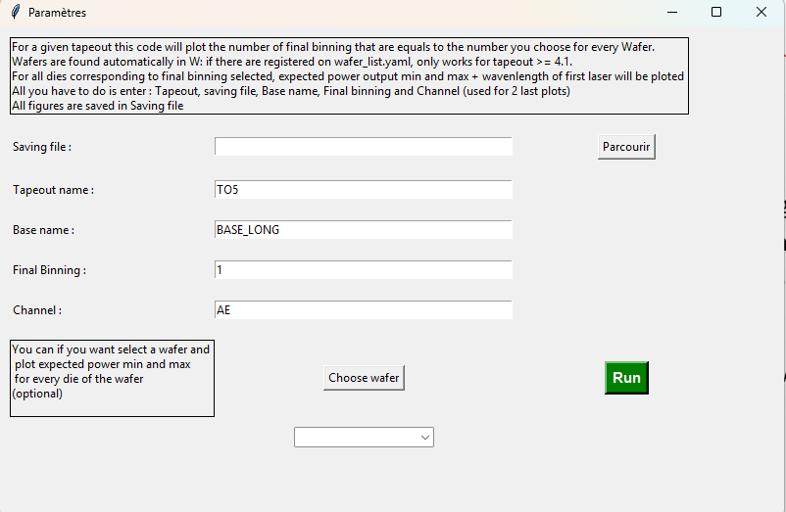
How to use :
-Select the saving folder which is the file where the figures will be saved by clicking on Choose
-Select the Tapeout you want to work with (only works for TO that are referred in W:\50-DEVELOPMENT\TEST\Temporary data database\wafer_list.yaml)
-Select the base name you want to work with
-Select the final binning (the figure will plot the number of dies with this Final Binning)
-Select the channel you want to plot expected power output min and max + wavenlength of first laser

OPTIONAL:
If you want to plot expected power output min and max for every die of a single wafer, click on choose wafer and select (below the button) the wafer you want
Finally, cluck on Run and wait for the processing to complete

